Workshop 3
Introduction
Generic Routing Encapsulation (GRE) is a tunneling protocol that can encapsulate a variety of network layer protocols between two locations over a public network, such as the Internet.
In this lab, you will configure an unencrypted point-to-point GRE tunnel and verify that network traffic is using the tunnel. You will also configure the OSPF routing protocol inside the GRE tunnel. The GRE tunnel is between the WEST and EAST routers in OSPF area 0. The ISP has no knowledge of the GRE tunnel. Communication between the WEST and EAST routers and the ISP is accomplished using default static routes.

Topology
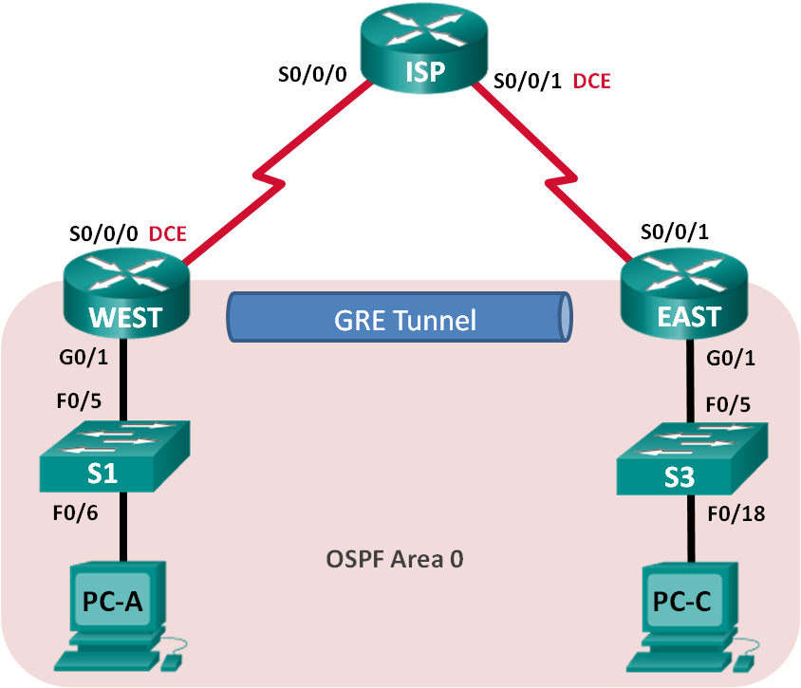

Addressing Table
Device | Interface | IP Address | Subnet Mask | Default Gateway
WEST | G0/1 | 172.16.1.1 | 255.255.255.0 | N/A
 | S0/0/0 (DCE) | 10.1.1.1 | 255.255.255.252 | N/A
 | Tunnel0 | 172.16.12.1 | 255.255.255.252 | N/A
ISP | S0/0/0 | 10.1.1.2 | 255.255.255.252 | N/A
 | S0/0/1 (DCE) | 10.2.2.2 | 255.255.255.252 | N/A
EAST | G0/1 | 172.16.2.1 | 255.255.255.0 | N/A
 | S0/0/1 | 10.2.2.1 | 255.255.255.252 | N/A
 | Tunnel0 | 172.16.12.2 | 255.255.255.252 | N/A
PC-A | NIC | 172.16.1.3 | 255.255.255.0 | 172.16.1.1
PC-C | NIC | 172.16.2.3 | 255.255.255.0 | 172.16.2.1

Objectives
Part 1: Configure Basic Device Settings
Part 2: Configure a GRE Tunnel
Part 3: Enable Routing over the GRE Tunnel

Further settings
Using a search engine research and compose the commands to create on a cisco router a default route to the ISP router. This should be composed and deployed on the WEST router and a similar one on the EAST router.
Test your partial connectivity using the ping command
- Between the PC’s and their respective default gateway
- Between each router and serial interfaces on the other routers.

Part 2 - Configure the GRE Tunnel Interface
For the WEST router
WEST(config)# interface tunnel 0
WEST(config-if)# ip address 172.16.12.1 255.255.255.252
WEST(config-if)# tunnel source s0/0/0
WEST(config-if)# tunnel destination 10.2.2.1

For the EAST router
EAST(config)# interface tunnel 0
EAST(config-if)# ip address 172.16.12.2 255.255.255.252
EAST(config-if)# tunnel source s0/0/1
EAST(config-if)# tunnel destination 10.1.1.1

Verify on both WEST and EAST routers that the tunnel interface is up
WEST#show ip interface brief
EAST#show ip interface brief

Issue the show interfaces tunnel 0 command to verify the tunneling protocol, tunnel source, and tunnel destination used in this tunnel.

Ping across the tunnel from the WEST router to the EAST router using the IP address of the tunnel interface.
WEST# ping 172.16.12.2

Use the traceroute command on the WEST router to determine the path to the tunnel interface on the EAST router.

Part 3 - Enable a routing protocol on the routers
Configure OSPF routing so that the LANs on the WEST and EAST routers can communicate using the GRE tunnel.
After the GRE tunnel is set up, the routing protocol can be implemented. For GRE tunneling, a network statement will include the IP network of the tunnel, instead of the network associated with the serial interface. just like you would with other interfaces, such as Serial and Ethernet. Remember that the ISP router is not participating in this routing process.

Configure OSPF routing for area 0 over the tunnel
    - Configure OSPF process ID 1 using area 0 on the WEST router for the 172.16.1.0/24 and 172.16.12.0/24 networks.
WEST(config)# router ospf 1
WEST(config-router)# network 172.16.1.0 0.0.0.255 area 0
WEST(config-router)# network 172.16.12.0 0.0.0.3 area 0

    - Configure OSPF process ID 1 using area 0 on the EAST router for the 172.16.2.0/24 and 172.16.12.0/24 networks.
EAST(config)# router ospf 1
EAST(config-router)# network 172.16.2.0 0.0.0.255 area 0
EAST(config-router)# network 172.16.12.0 0.0.0.3 area 0

Verify OSPF routing
Issue the show ip route command on both routers
  - Verify OSPF routing.
    - From the WEST router, issue the show ip route command to verify the route to 172.16.2.0/24 LAN on the EAST router.
    - From the EAST router issue the command to verify the route to 172.16.1.0/24 LAN on the WEST router.
  - Verify end-to-end connectivity.
    - Ping from PC-A to PC-C. It should be successful. If not, troubleshoot until you have end-to-end connectivity.
Note: It may be necessary to disable the PC firewall to ping between PCs.
    - Traceroute from PC-A to PC-C. What is the path from PC-A to PC-C?

DEMONSTRATE TO YOUR TUTOR

Research questions for your portfolio
- What is a tunnel used for?
- How would you make it secure?

